1. Setup VM, Linux, and basic testing – must take screenshots at each step to receive points

1.b. Dowload Oracle VirtualBox 6.1.36

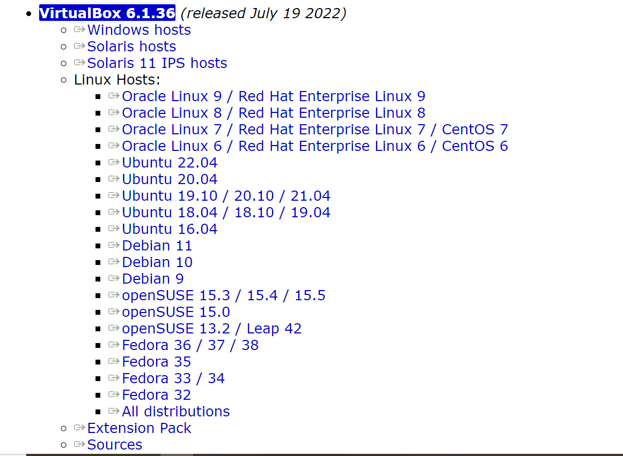

1.c. Install Virtual Box

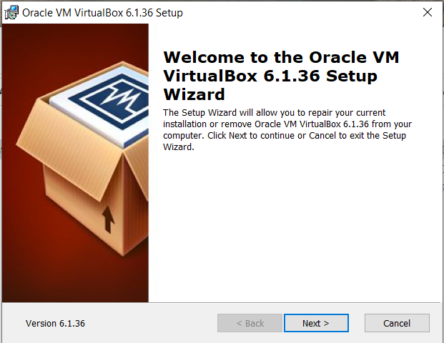

1.d. Download and install Ubuntu Desktop 22.04.3

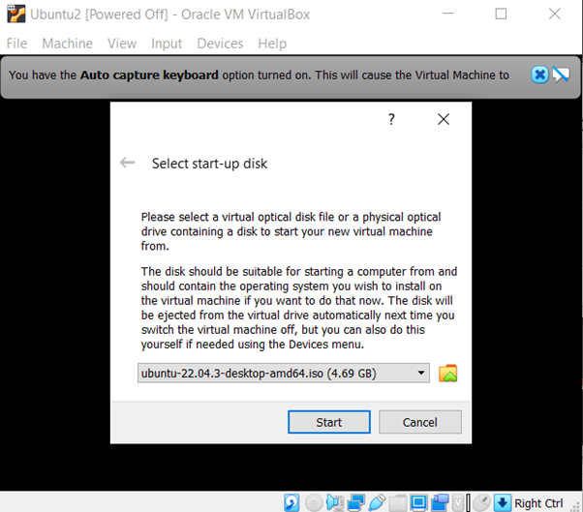

1.e. Create Virtual Machine (VM), to support Linux, Ubuntu, 64-bit, 4GB RAM, Virtual Disk 25GB, VDI image, dynamically allocated, 2-core, and a network interface (1GbE or WiFi) with NAT support.

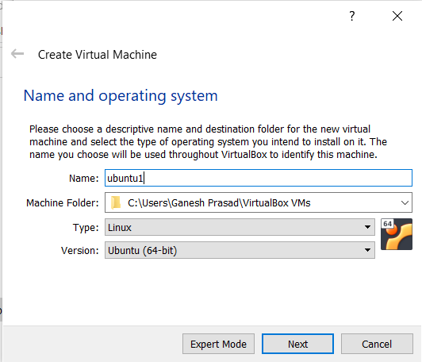

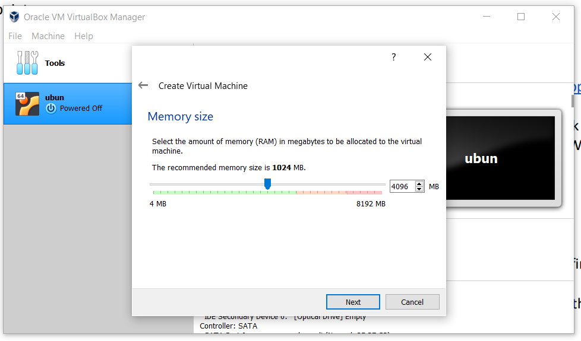

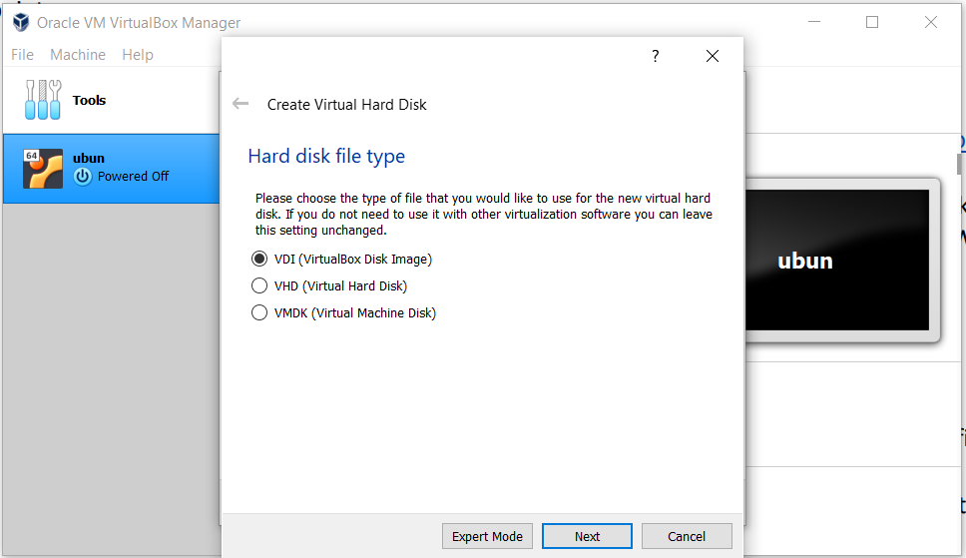

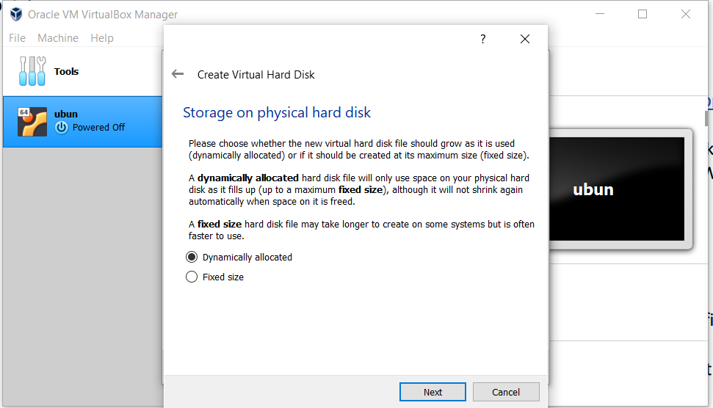

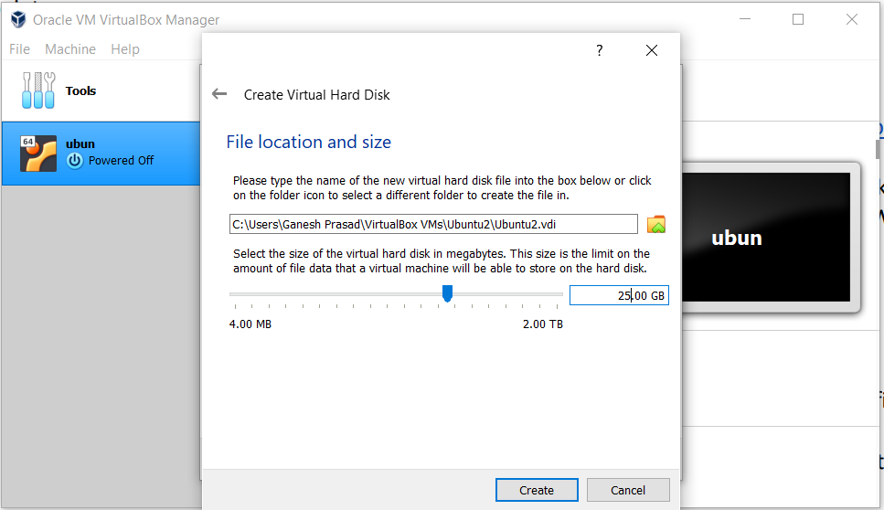

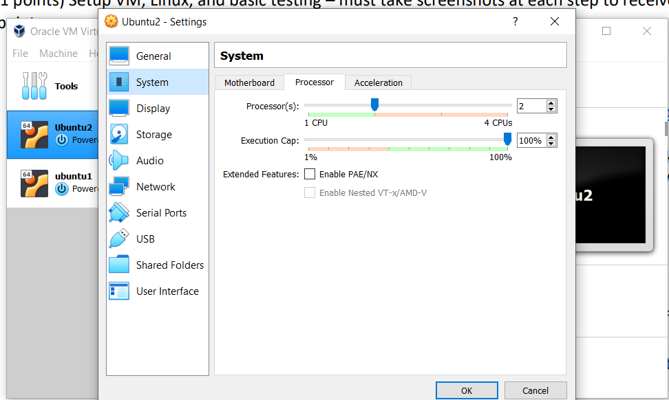

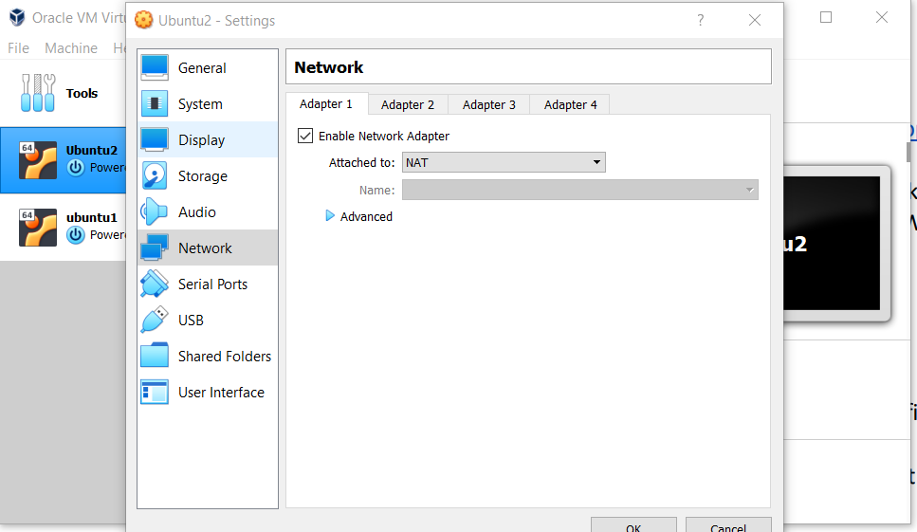

1.f. Install Linux from the ISO image

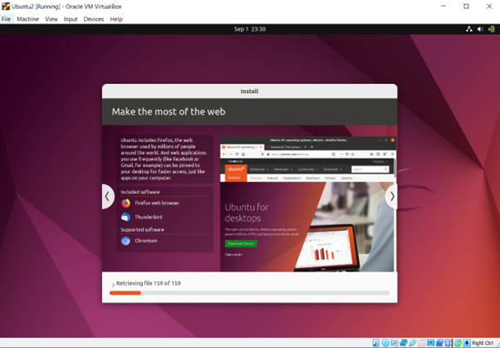

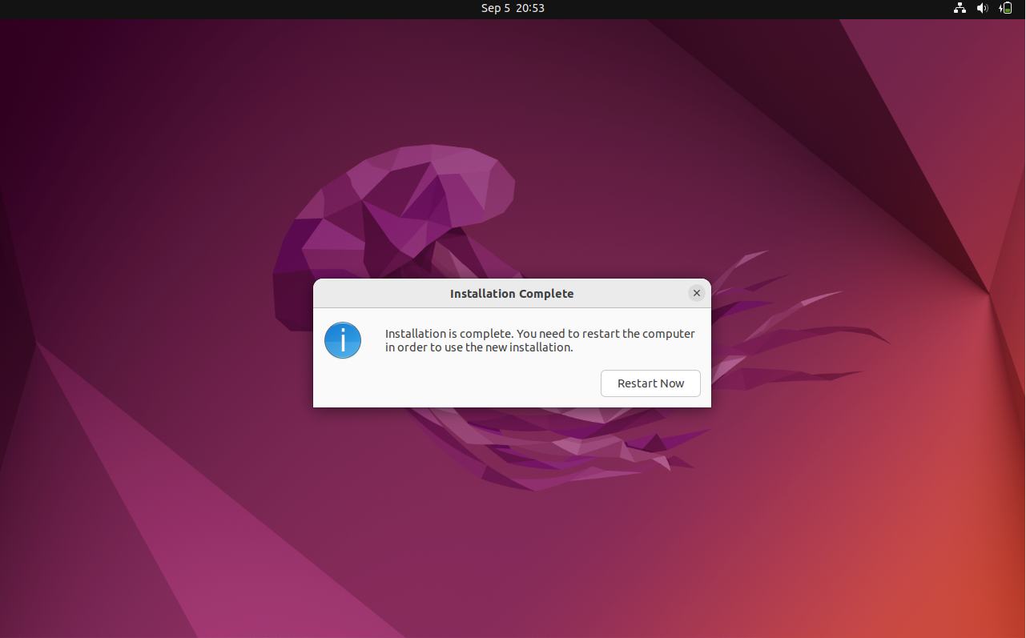

1.g. Create a user id and password.

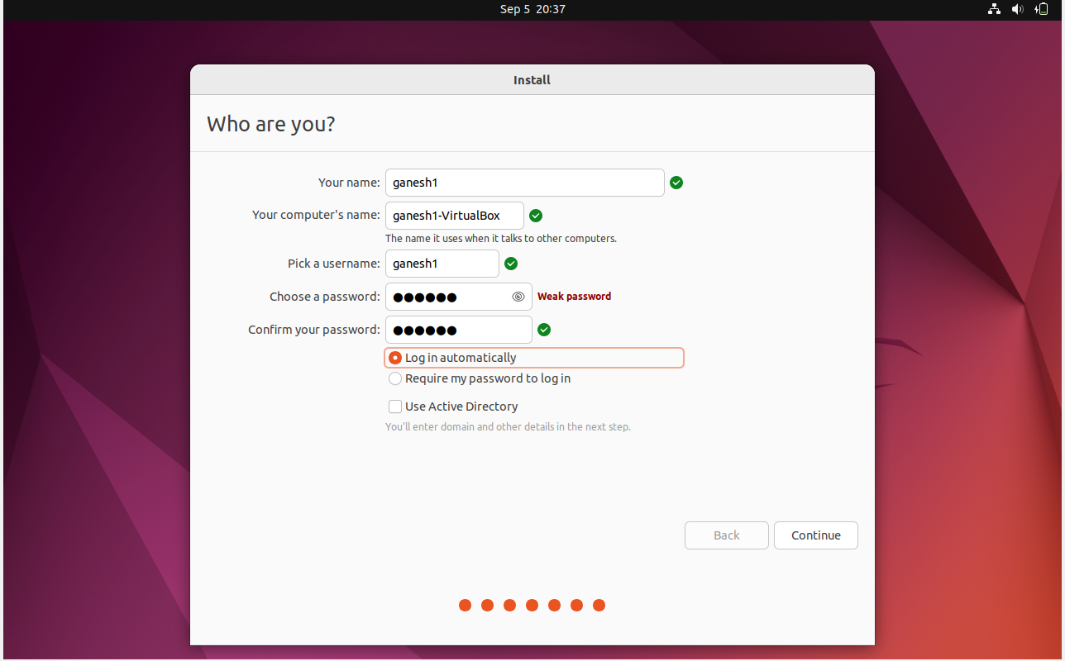

1.h. Turn on Firewall and block all ports.

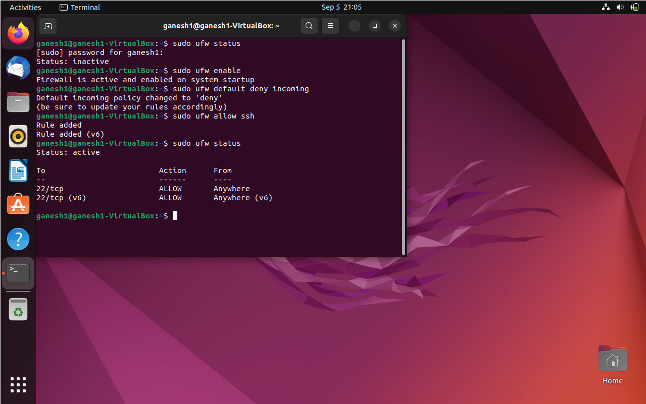

1.i. Enable SSH access to your new Linux installation; open SSH port in firewall

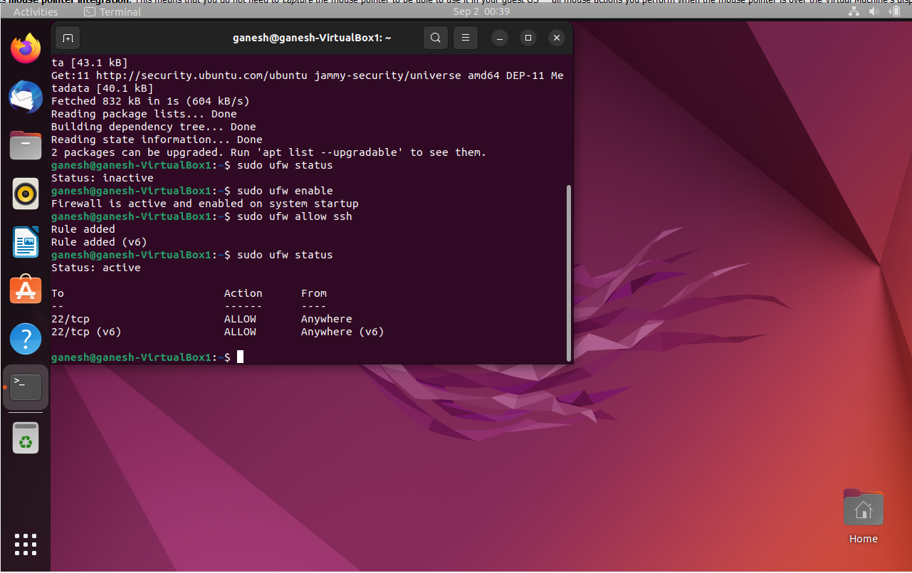

1.j. Repeat steps e through i, and create another VM with the same specifications as the first one.

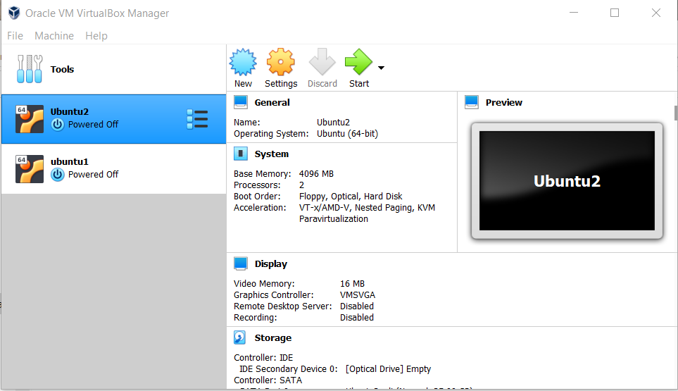

1.k. Create private/public keys and install them properly in both of your new VMs. Test that you can connect remotely to your VMs with your keys, from one VM to the other VM.

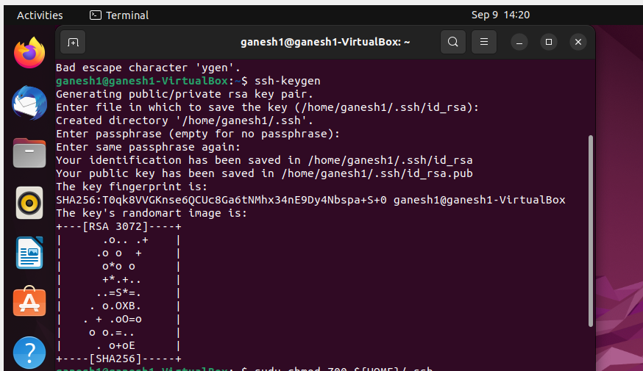

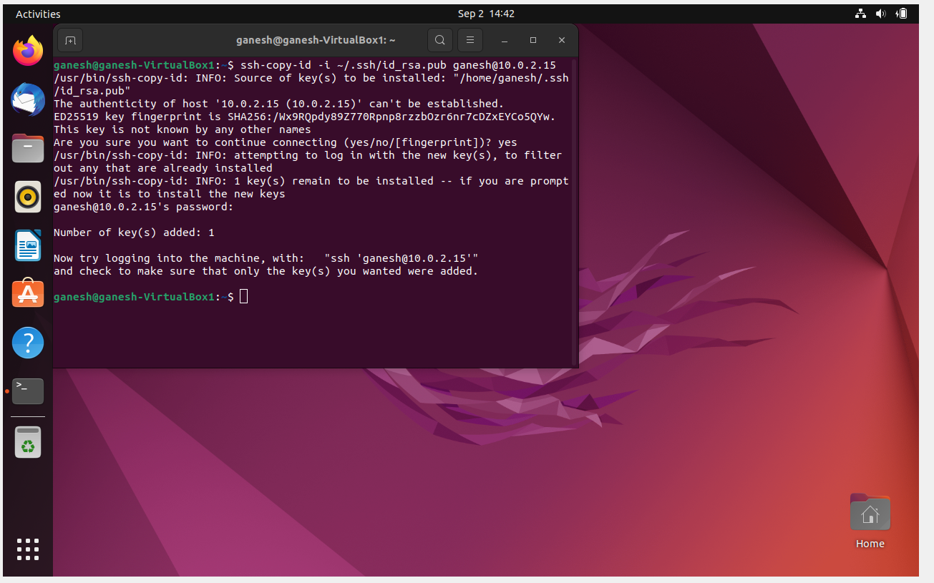

1. Test connection VM1 to VM2

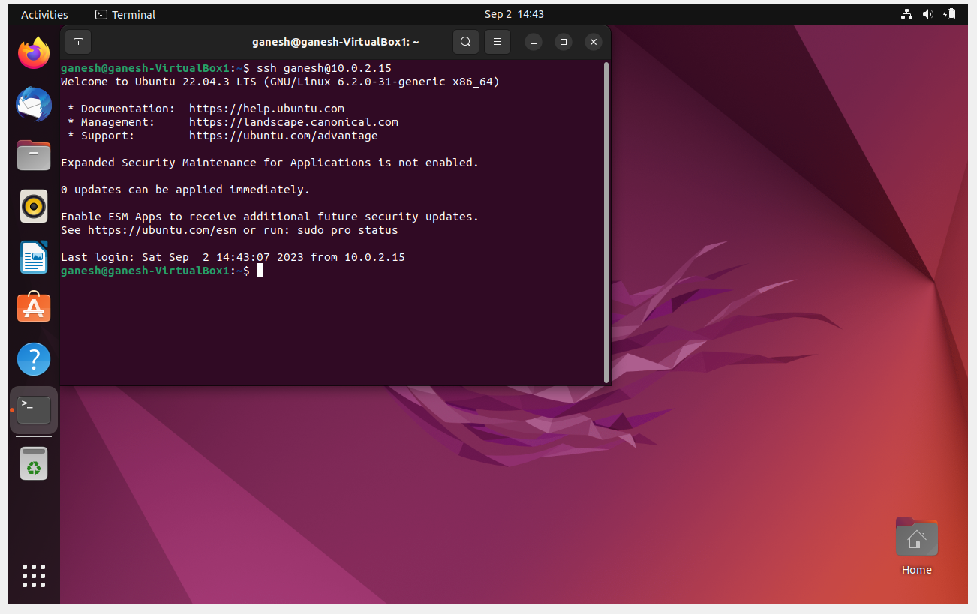

1. VM2 to VM1 connection

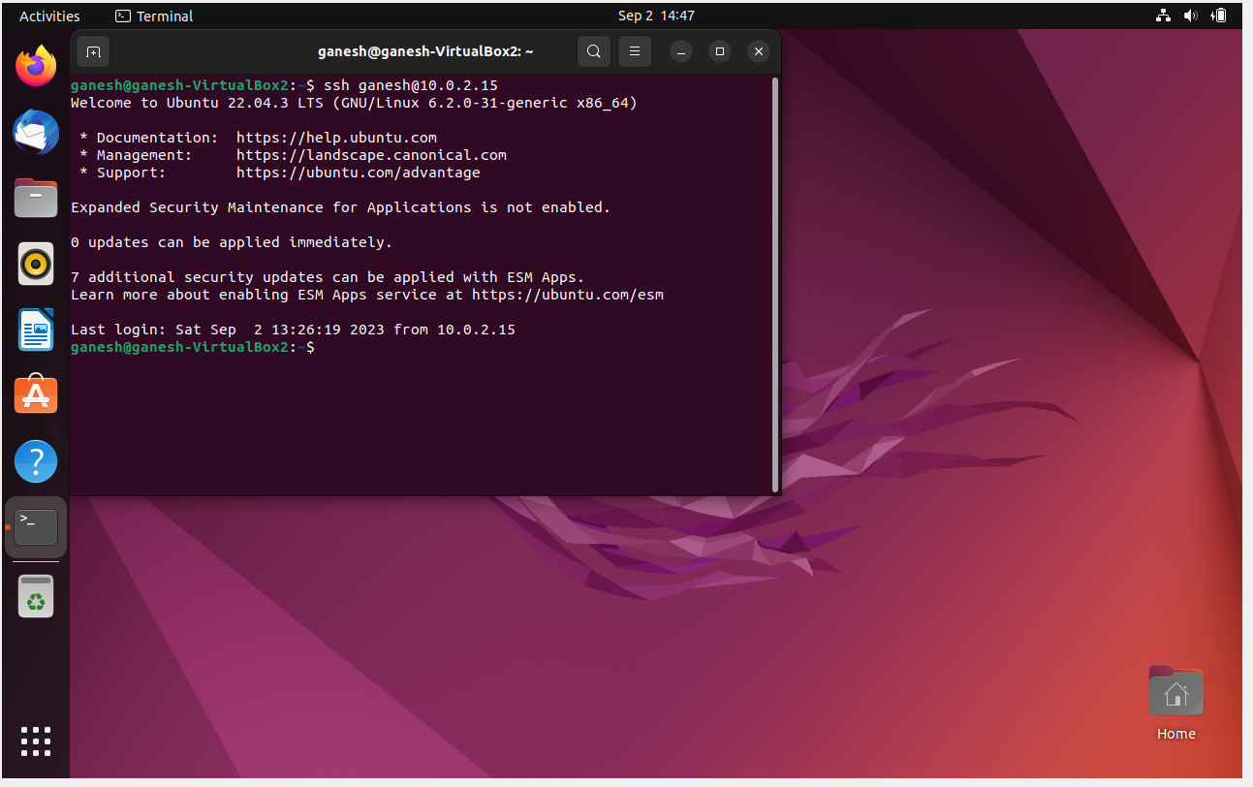

2.a. ssh – this command is to connect to a remote SSH server

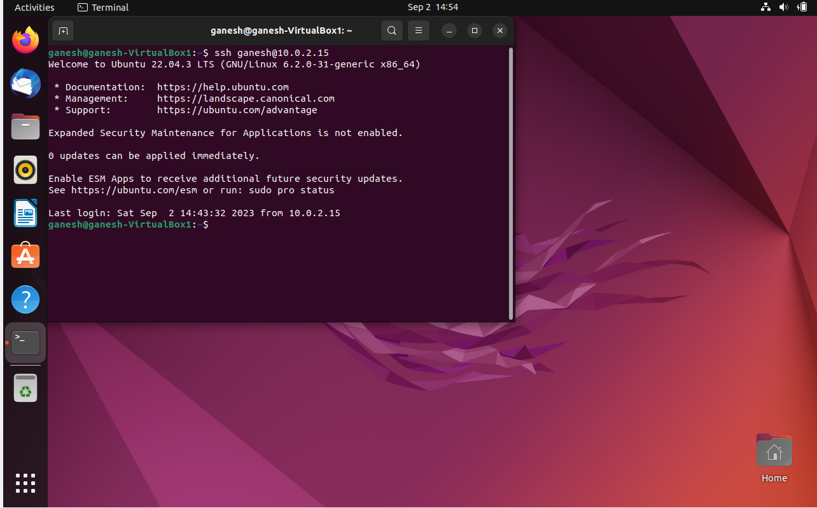

2.b. ssh-keygen – this command is to create a public and private key pair

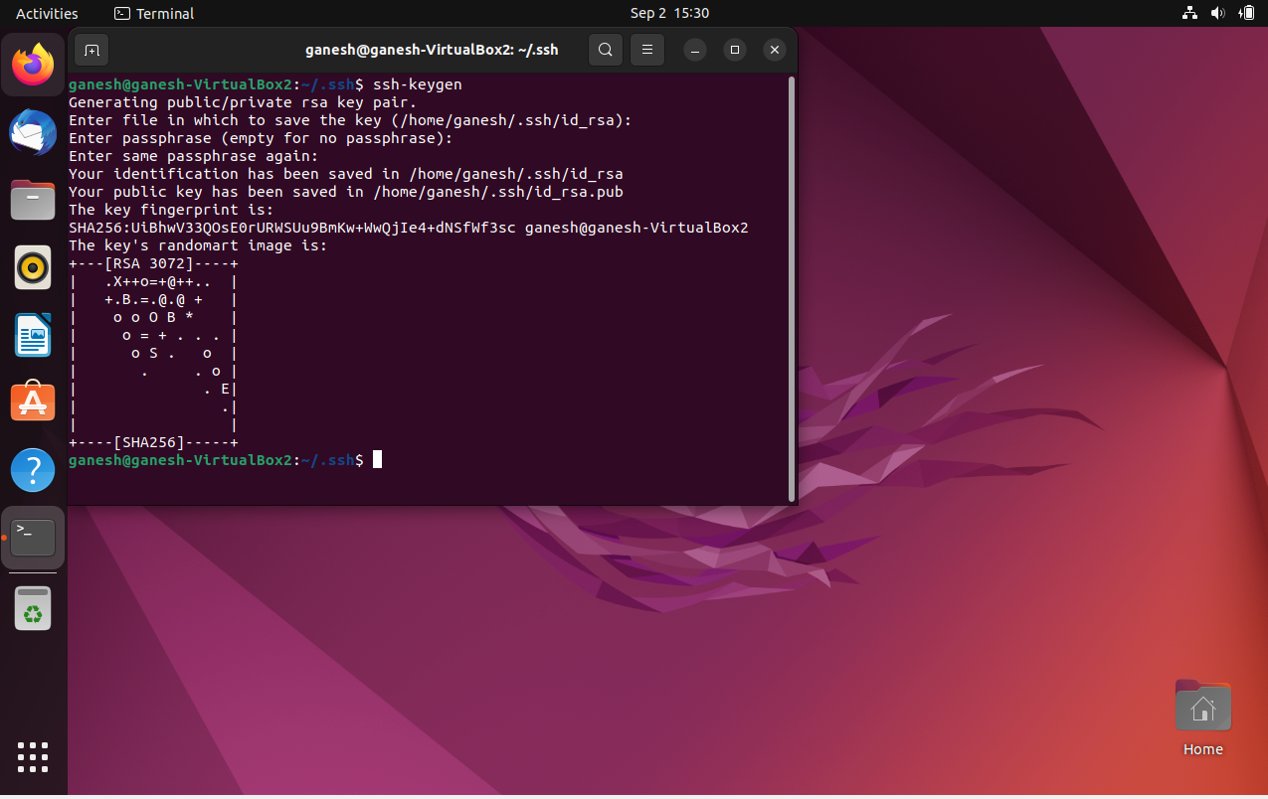

2.c. scp - used to transfer files from one system to a remote server.

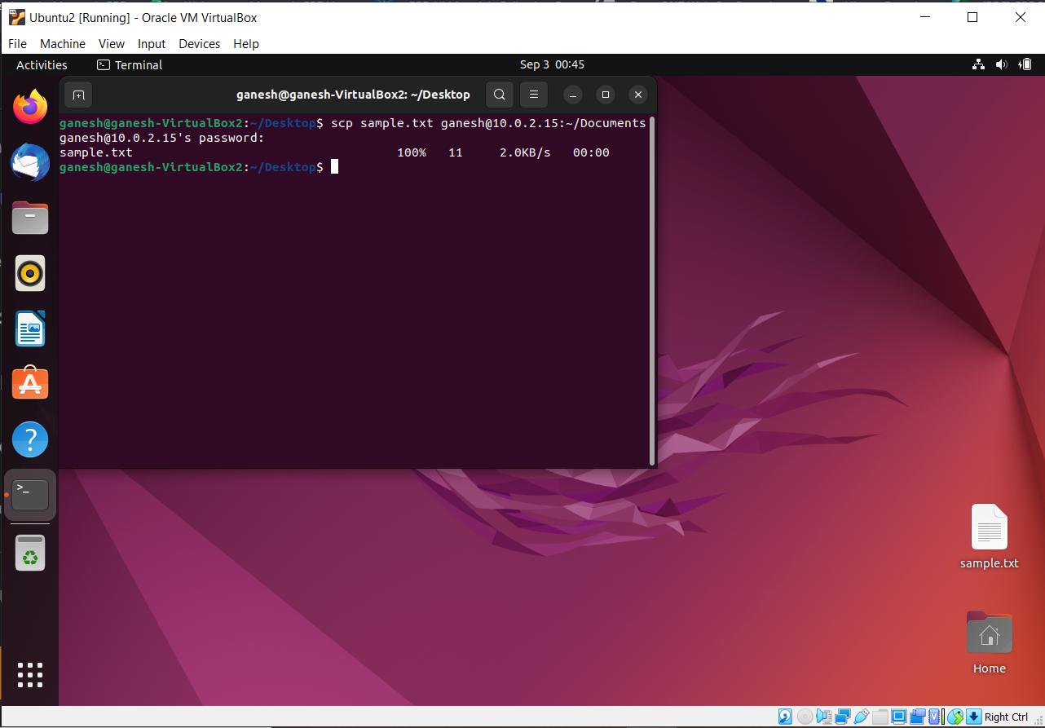

2.d. history - lists all the commands entered in the past

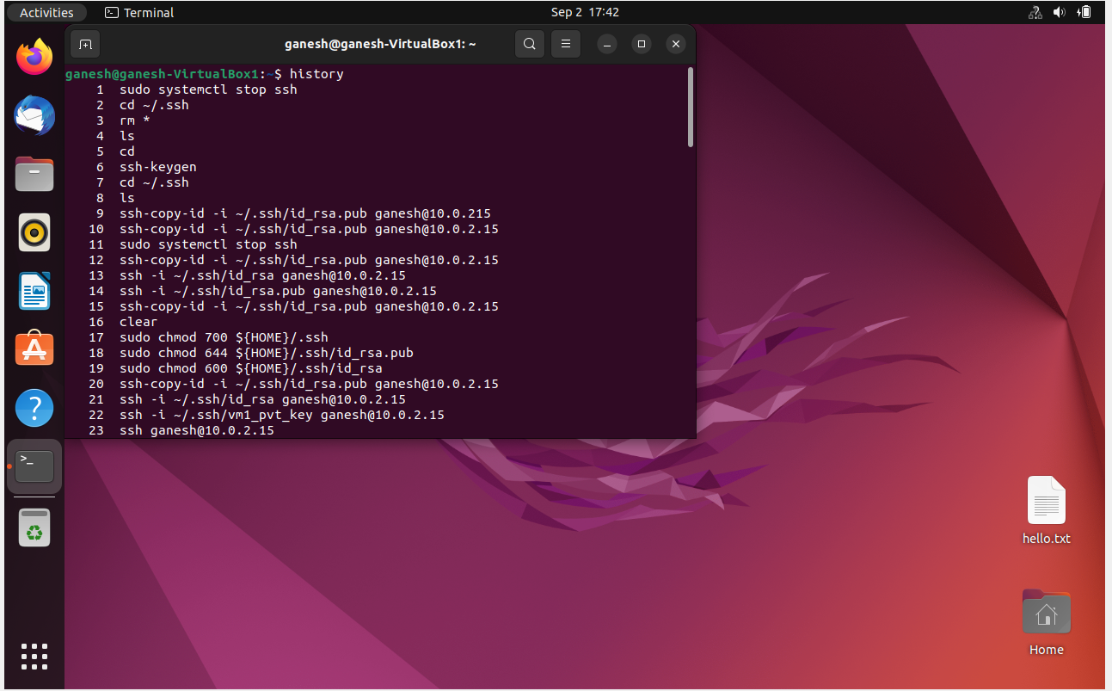

2.e. Running any command with SuperUser Privilege

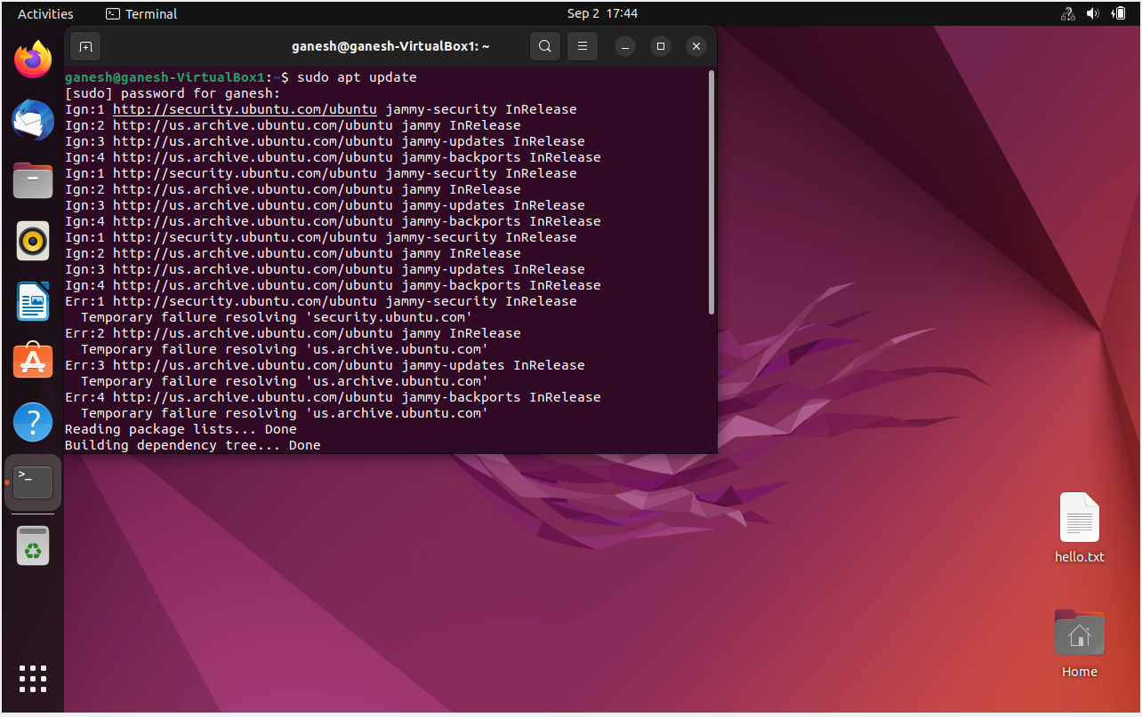

2.f. ip – fetch network related information

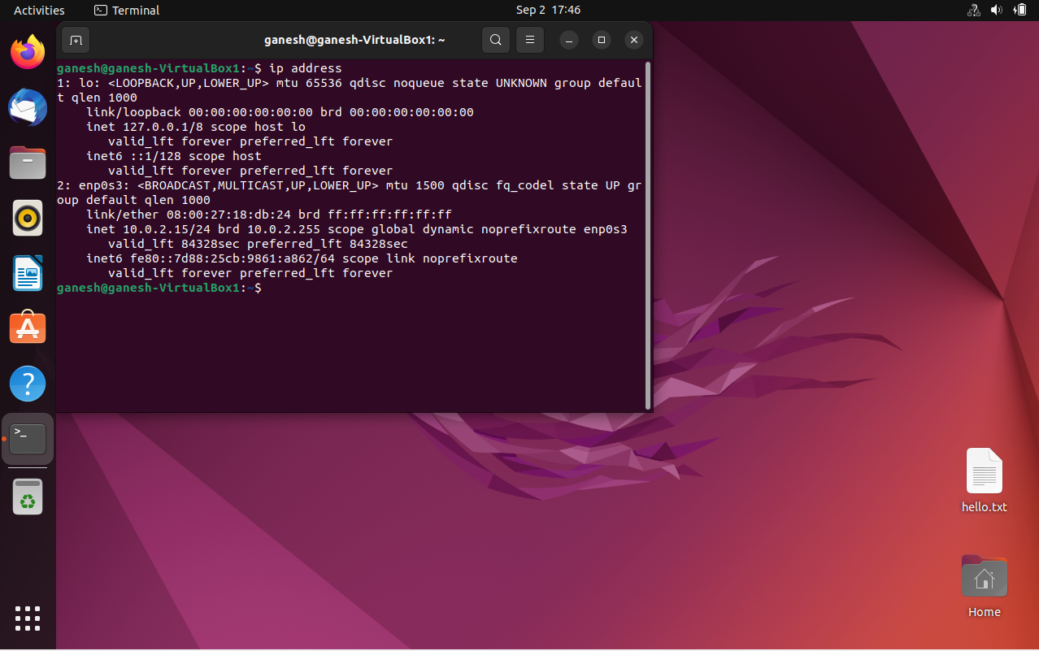

2.g. dd – This command is used for creating disk images, copying data from one machine to another.

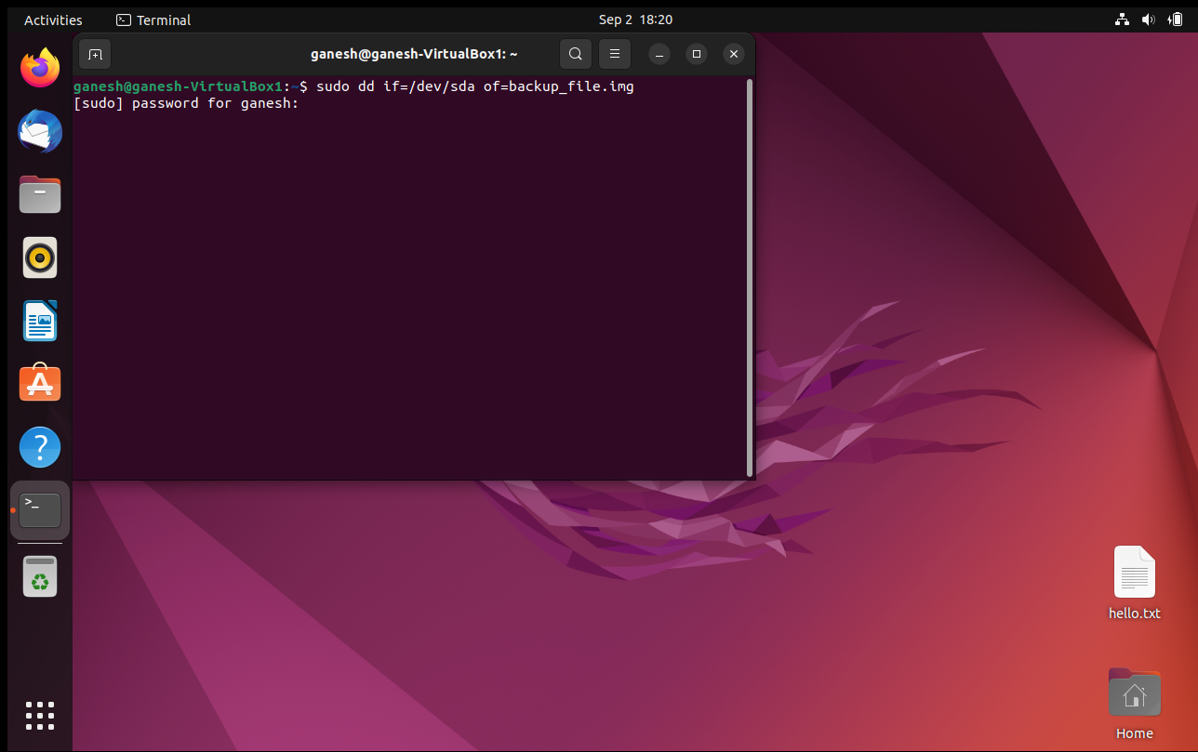



2.h. fdisk- this commands helps us to partition a disk

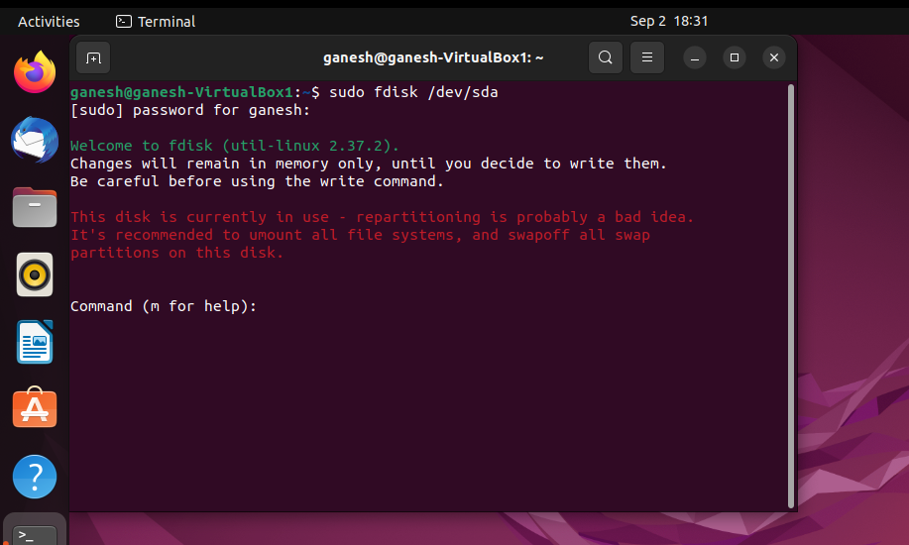

2.i apt – it is used to manage updates for Linux systems, software packages. apt is a package management tool

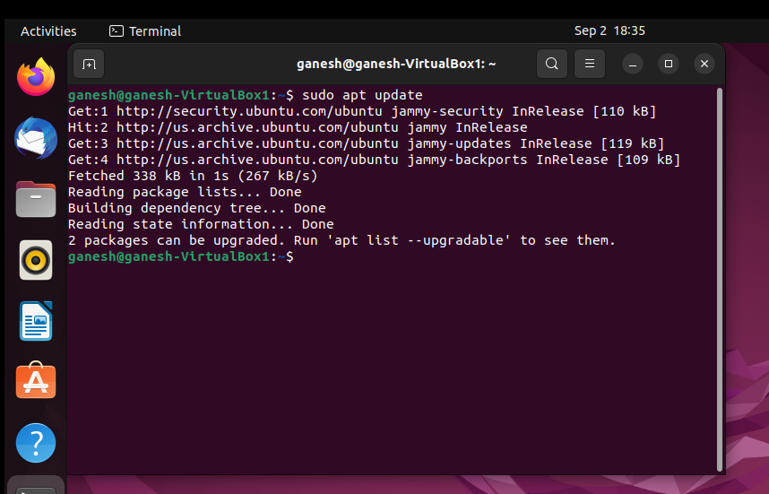

2.j. vi- this is text editor used to edit content of files.

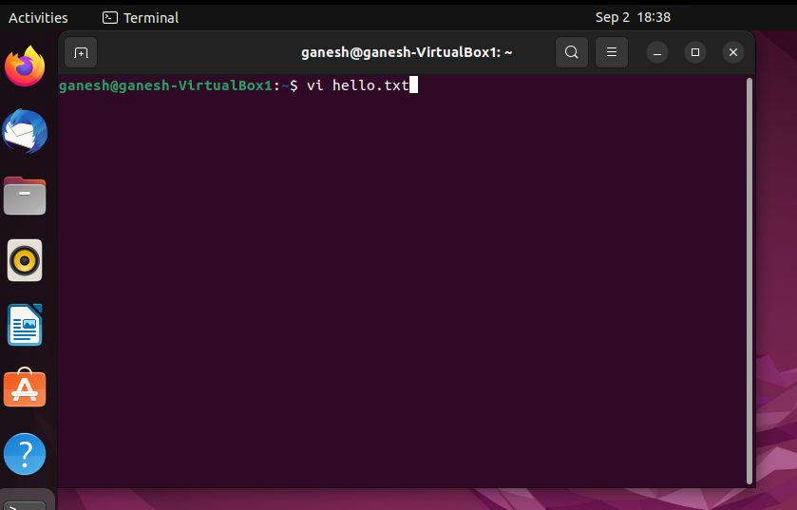

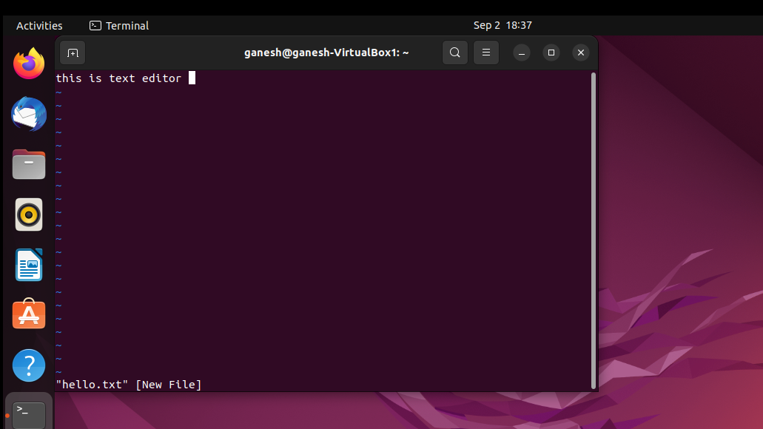

2.k. time- it is used to measure the time taken to execute a particular command, which includes system time to too.

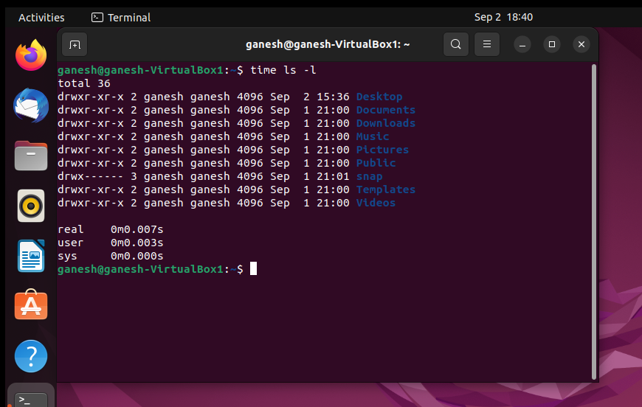

2.l. tar – is used to create compress and archive files

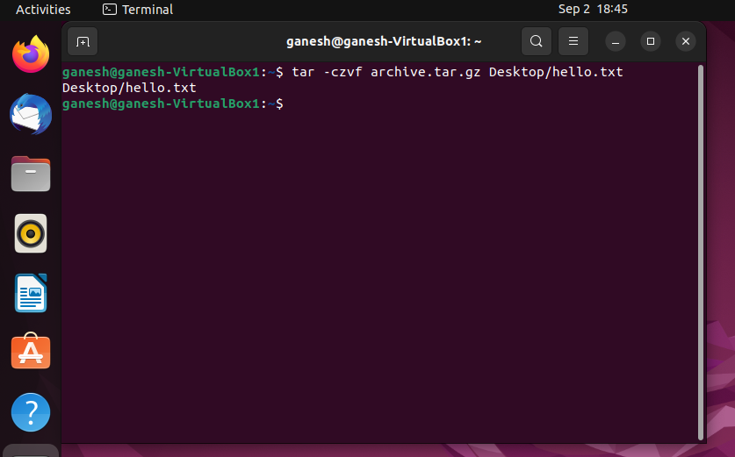

2.m. cat – this command displays the contents of the file

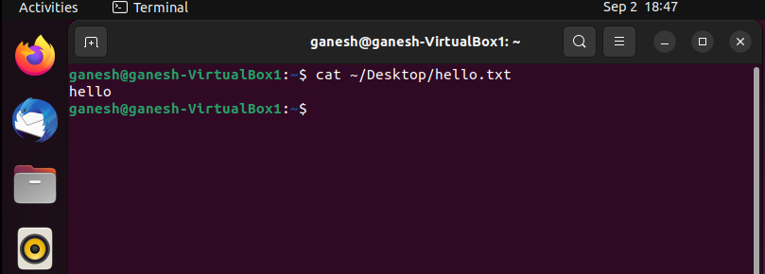

2.n. watch- it is used to repeatedly execute a command and display result in a terminal window

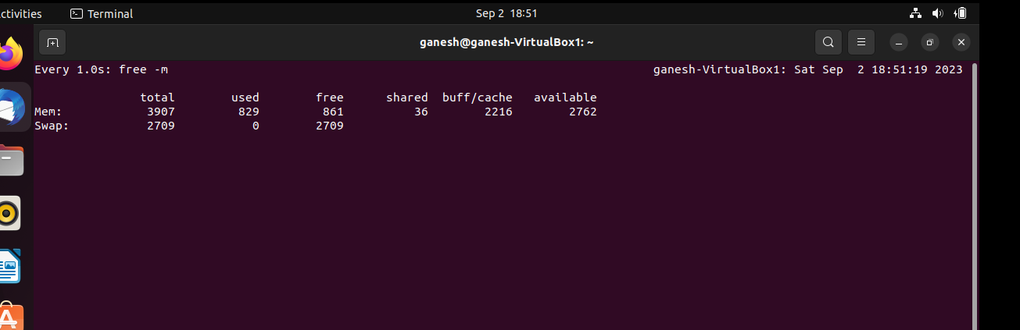

2.o. ps – ps lists all running process.

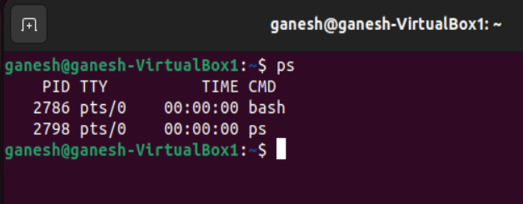

2.p. top – get resource usage details in real time.

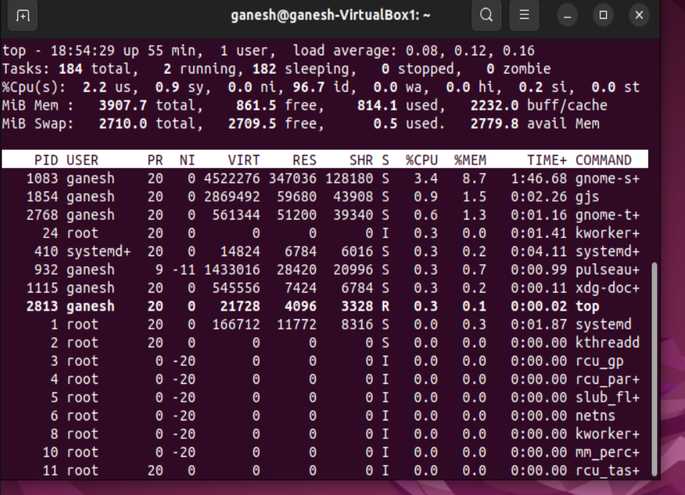

2.q. htop – provides interactive view of the system processes for monitoring.

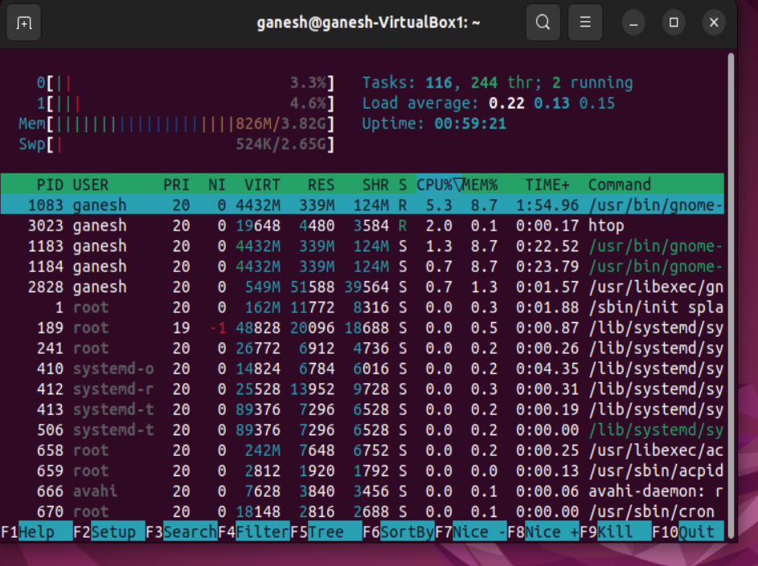

2.r. gcc – gcc is a complier, used to compile languages including C /C++ codes.

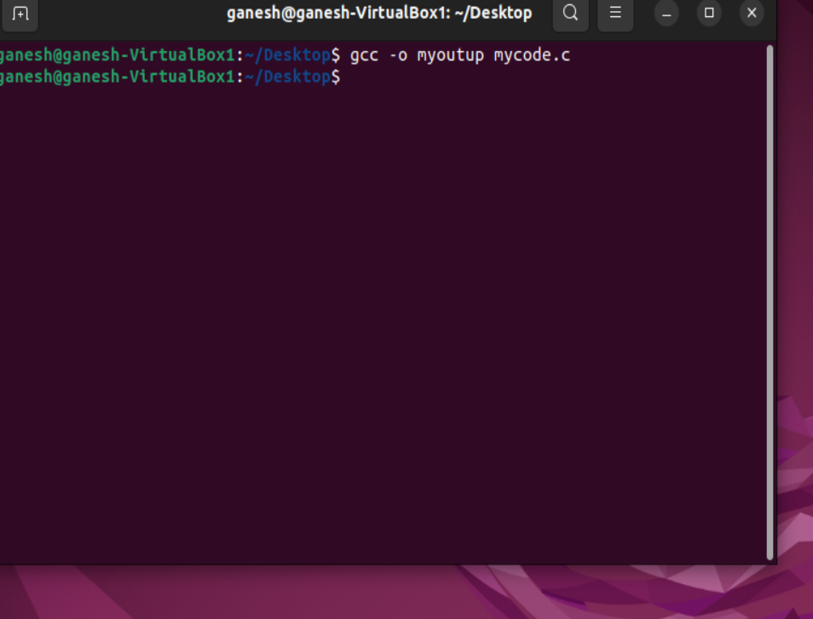

2.s. tail – it is used to display last lines of a text file

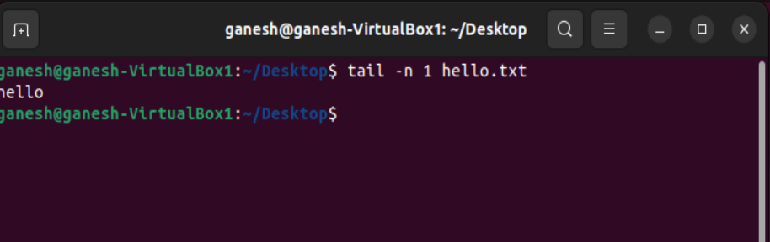

2.t. grep – search for a string pattern in a text file.

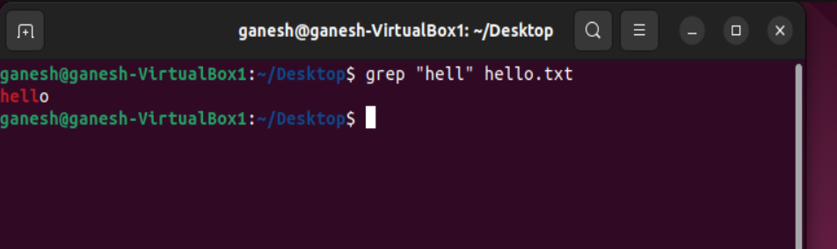

2.u. kill – to end a process with the help of a process ID

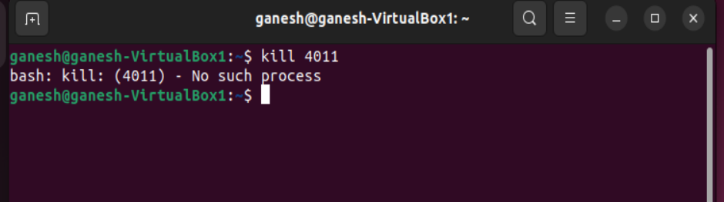

2.v. killall – similar to kill, used to terminate a process by name

2.w. du – get current disk usage status

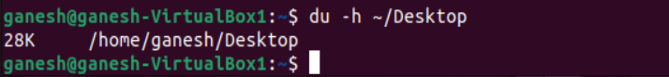

2.x. df – get disk space usage

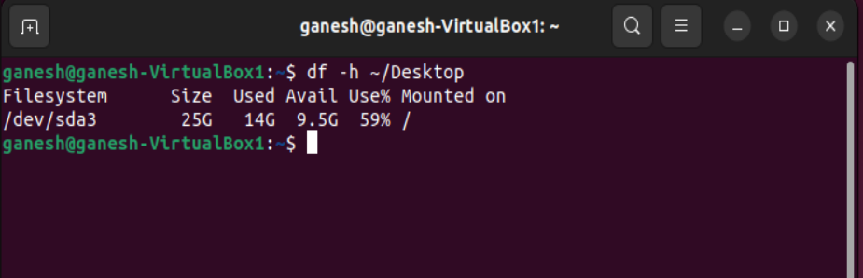

2.y. screen – flexibility to create and manage multiple terminal sessions

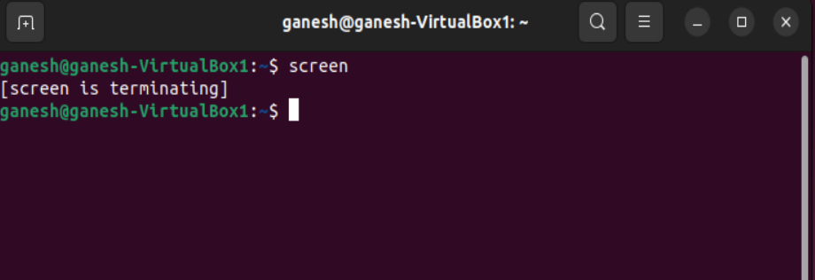

2.z. vim – vim is a text editor

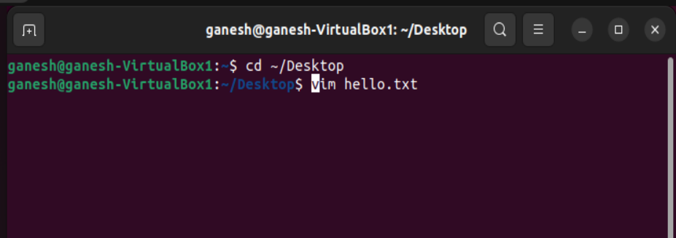

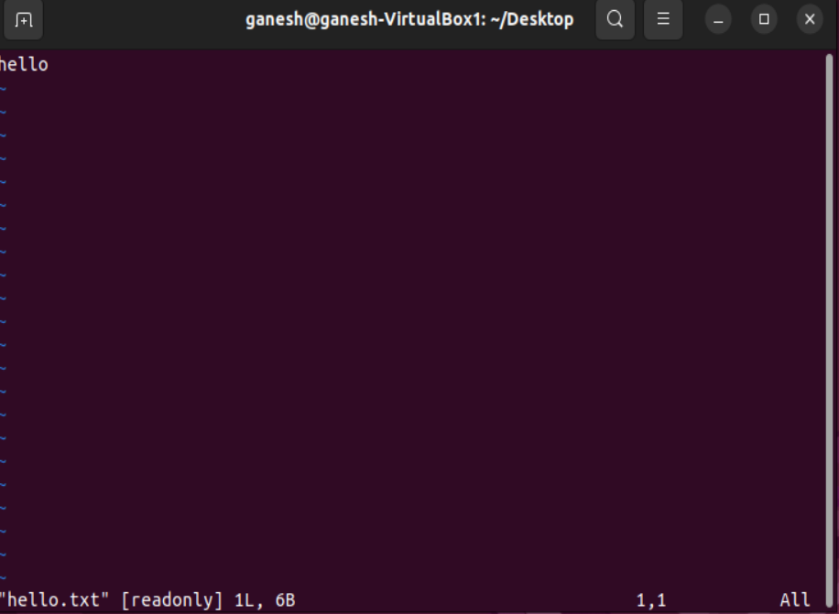

2.aa. chmod – provide/change file permission such as read, write, execute to owner, user, group

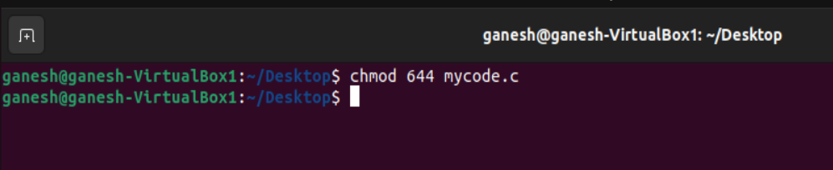

2.bb. chown – update ownership/group for a particular file/directory.

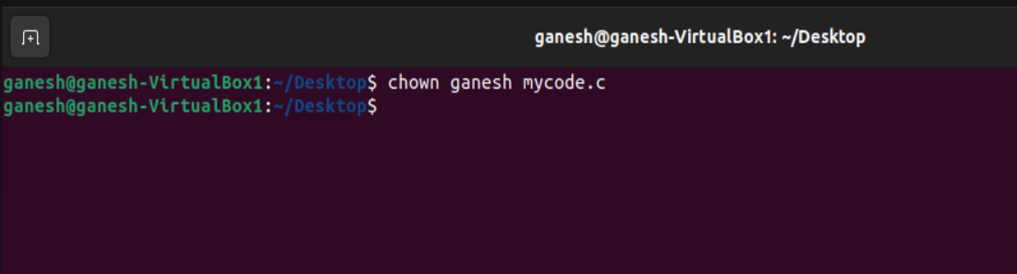

2.cc. useradd – create a new user profile

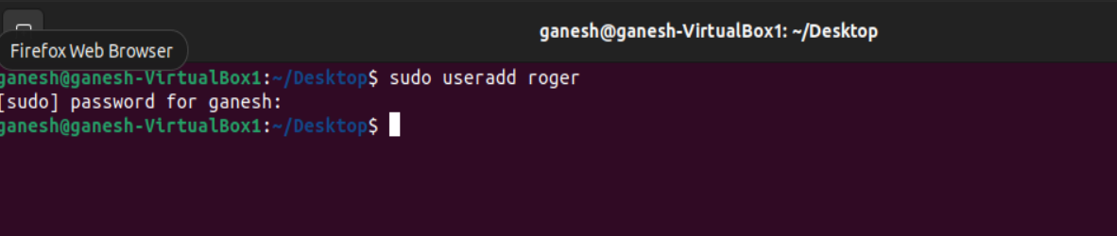

2.dd. man – to display manual/more information for a command and much more.

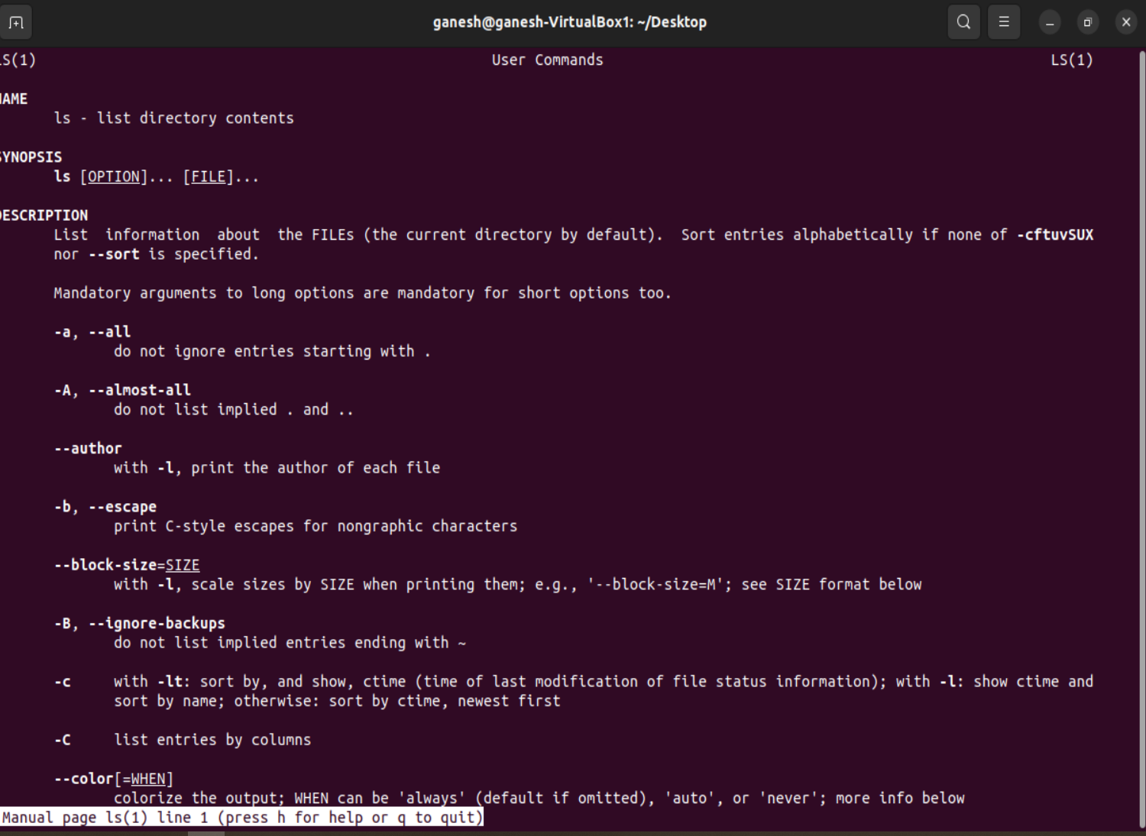

2.ee. locate – quickly find items by its name

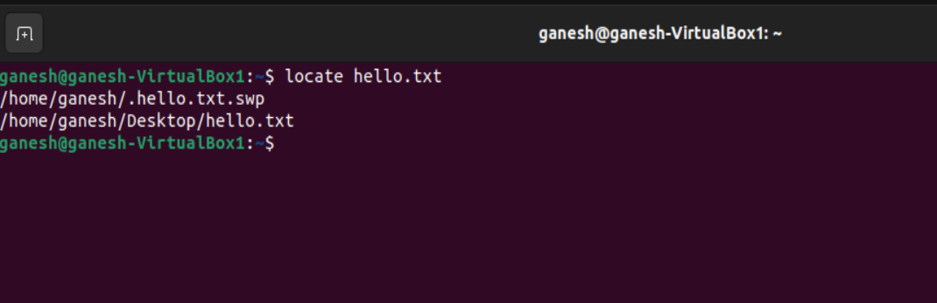

2.ff. find – this command helps to find files and directories.

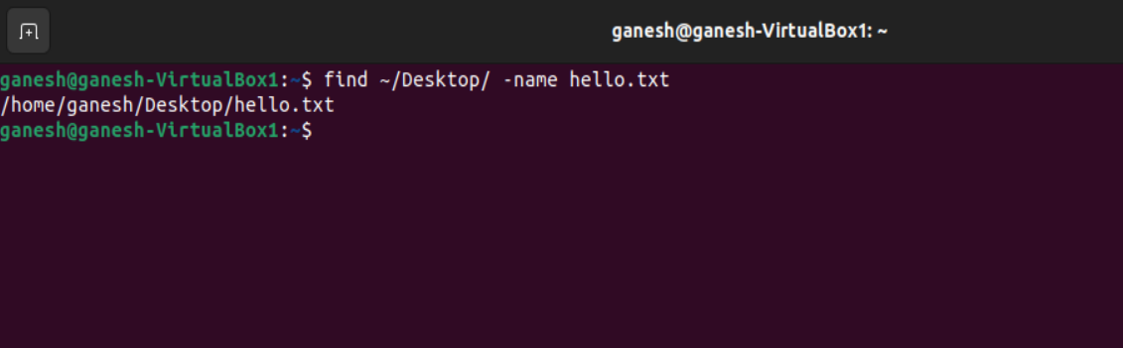

2.gg. sed – stands stream editor used for string manipulation and used perform text related operations

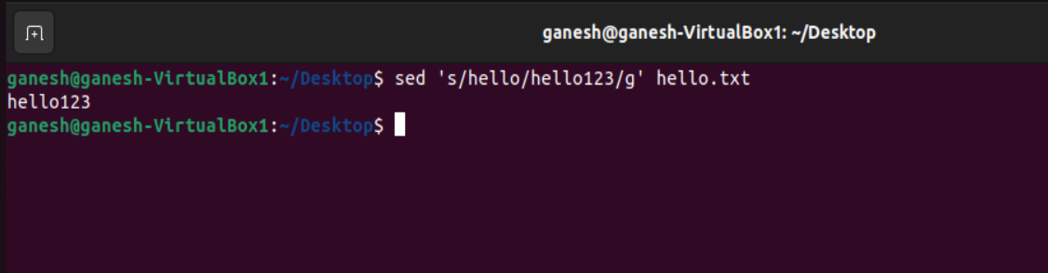

2.hh. awk – this is used for text analysis/manipulation like pattern matching, filtering data from files

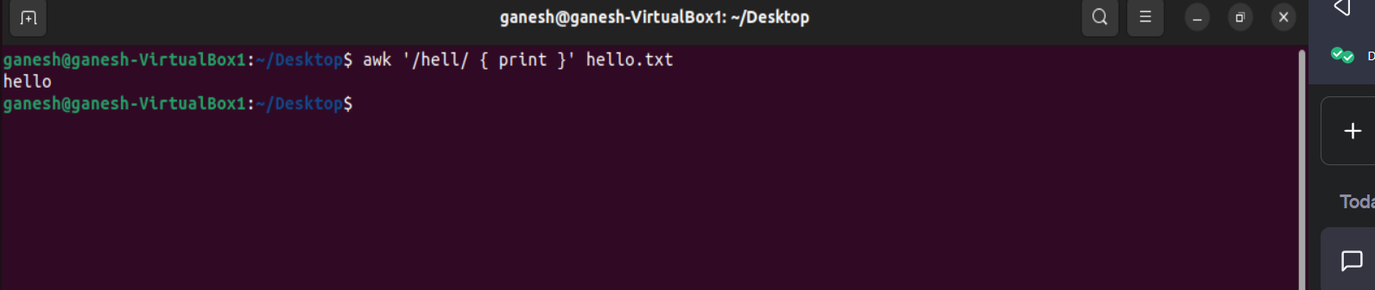

2.ii. diff – this command is used for file comparison.

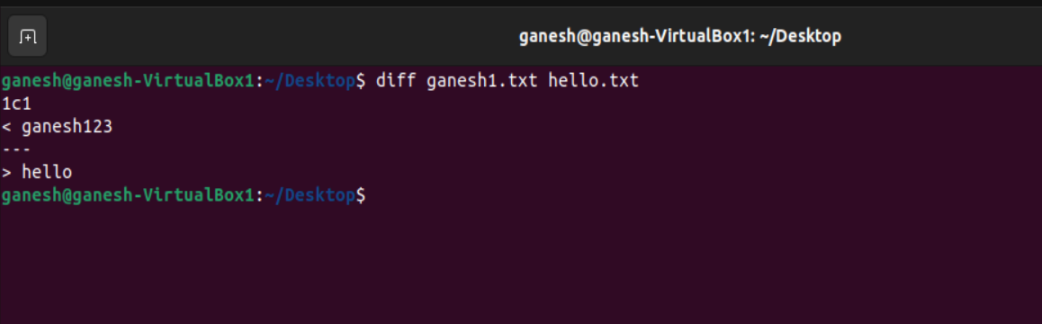

2.jj. sort – arrange the lines of the text alphabetically

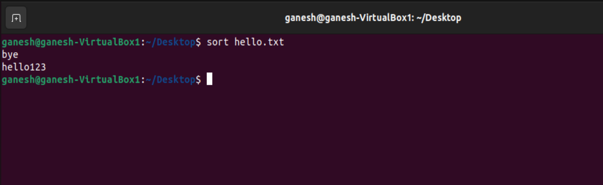

2.kk. export – it is used to set environment variables and make the same available for child processes too.

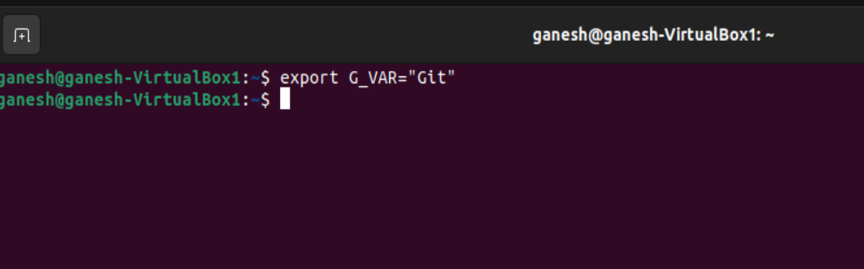

2.ll. pwd – fetch current directory

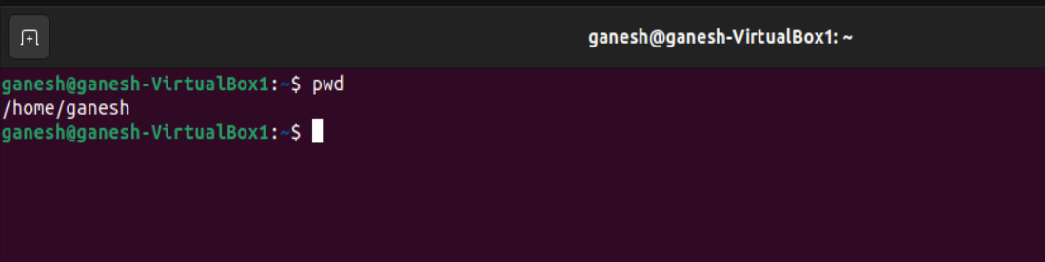2.mm. crontab – used to schedule and manage tasks that execute at configured intervals on a regular basis.

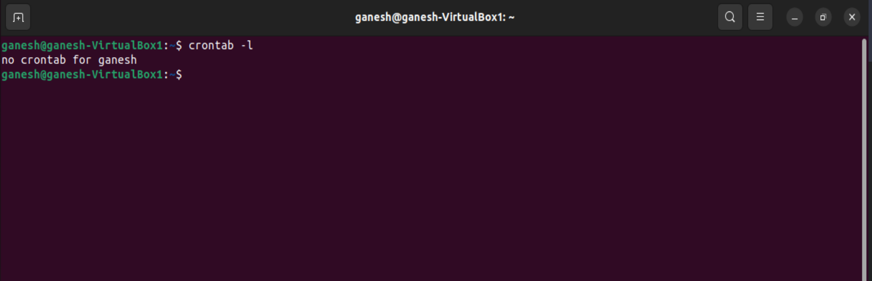

2.nn. mount – this command is used to attach a filesystem to a system directory.



2.oo. passwd – used to change user account password.

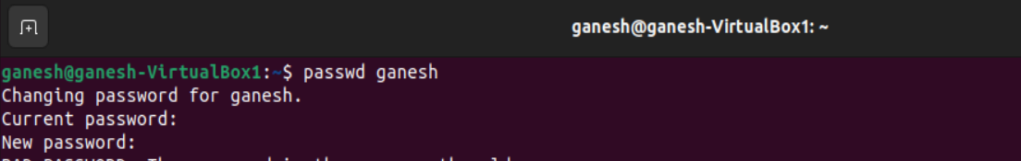

2.pp. uname – to display information about the system.

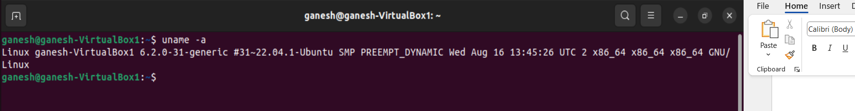

2.qq. whereis – this helps in getting the binary, documentation, source code for a command

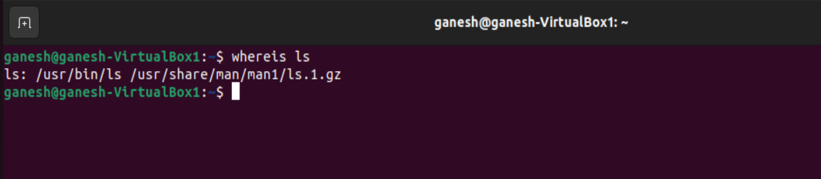

2.rr. whatis – gives a brief description of the command given

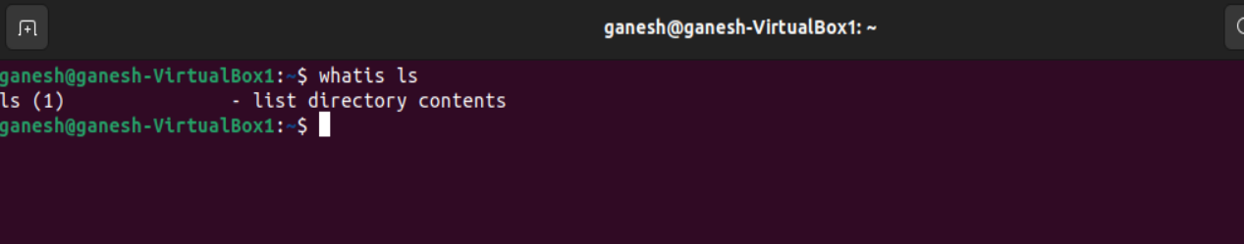

2.ss. su – used to switch to another available user

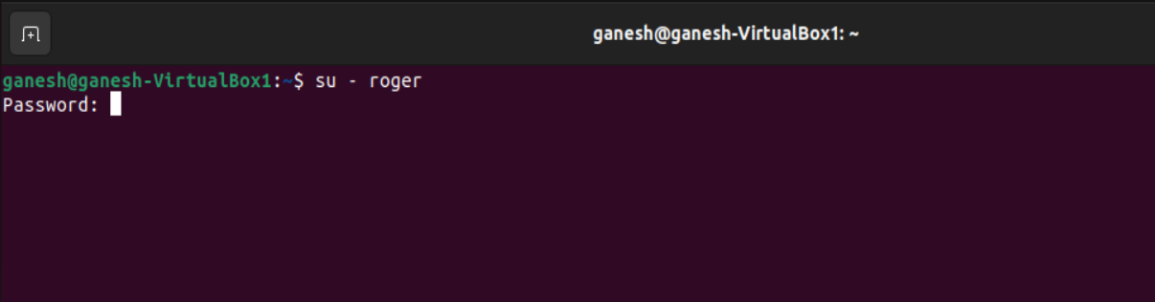

2.tt. ping – used for testing network connectivity

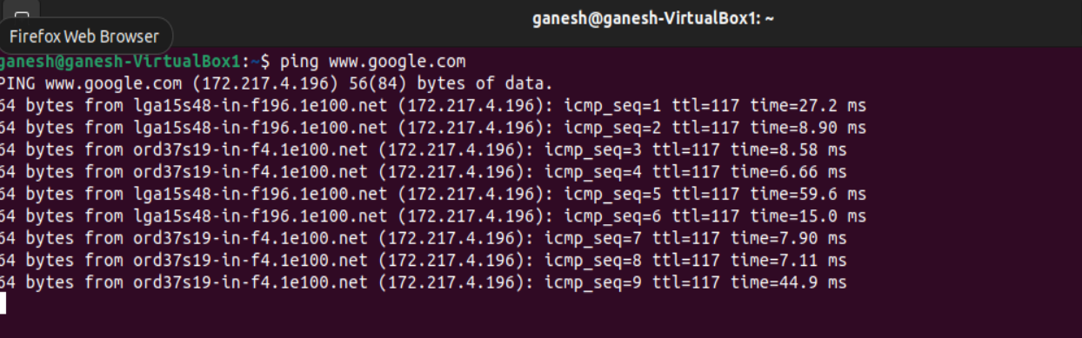

2.uu. traceroute – used to track packets and the hops that is taken from source to destination host in a network

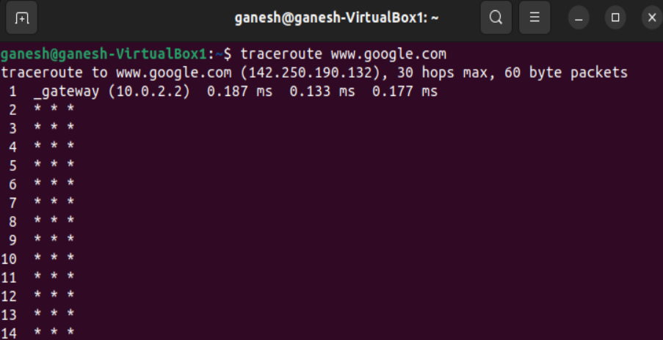

2.vv. date – fetch current date and time

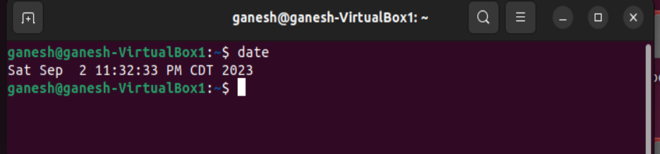

2.ww. time – get the command execution time

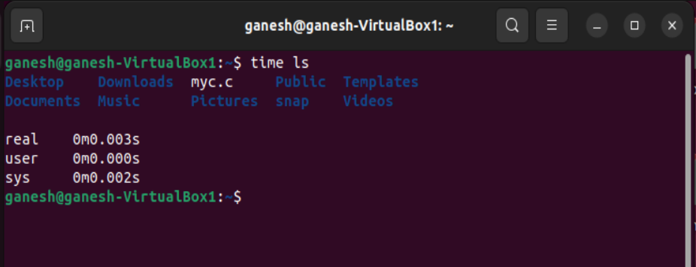

2.xx. wget – download files over the internet, web servers

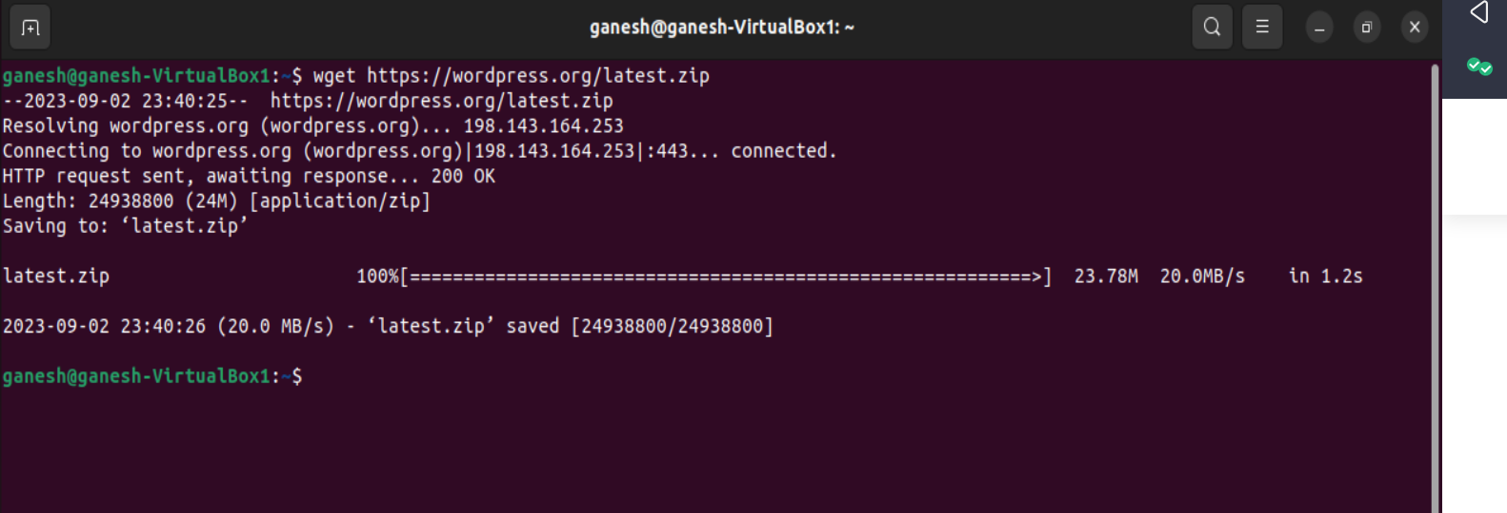

2.yy. wc – used to count the number of lines, words, total characters in the file specified.

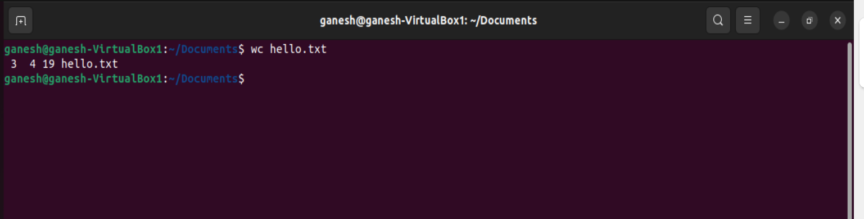

2.zz. pwgen – generate random passwords

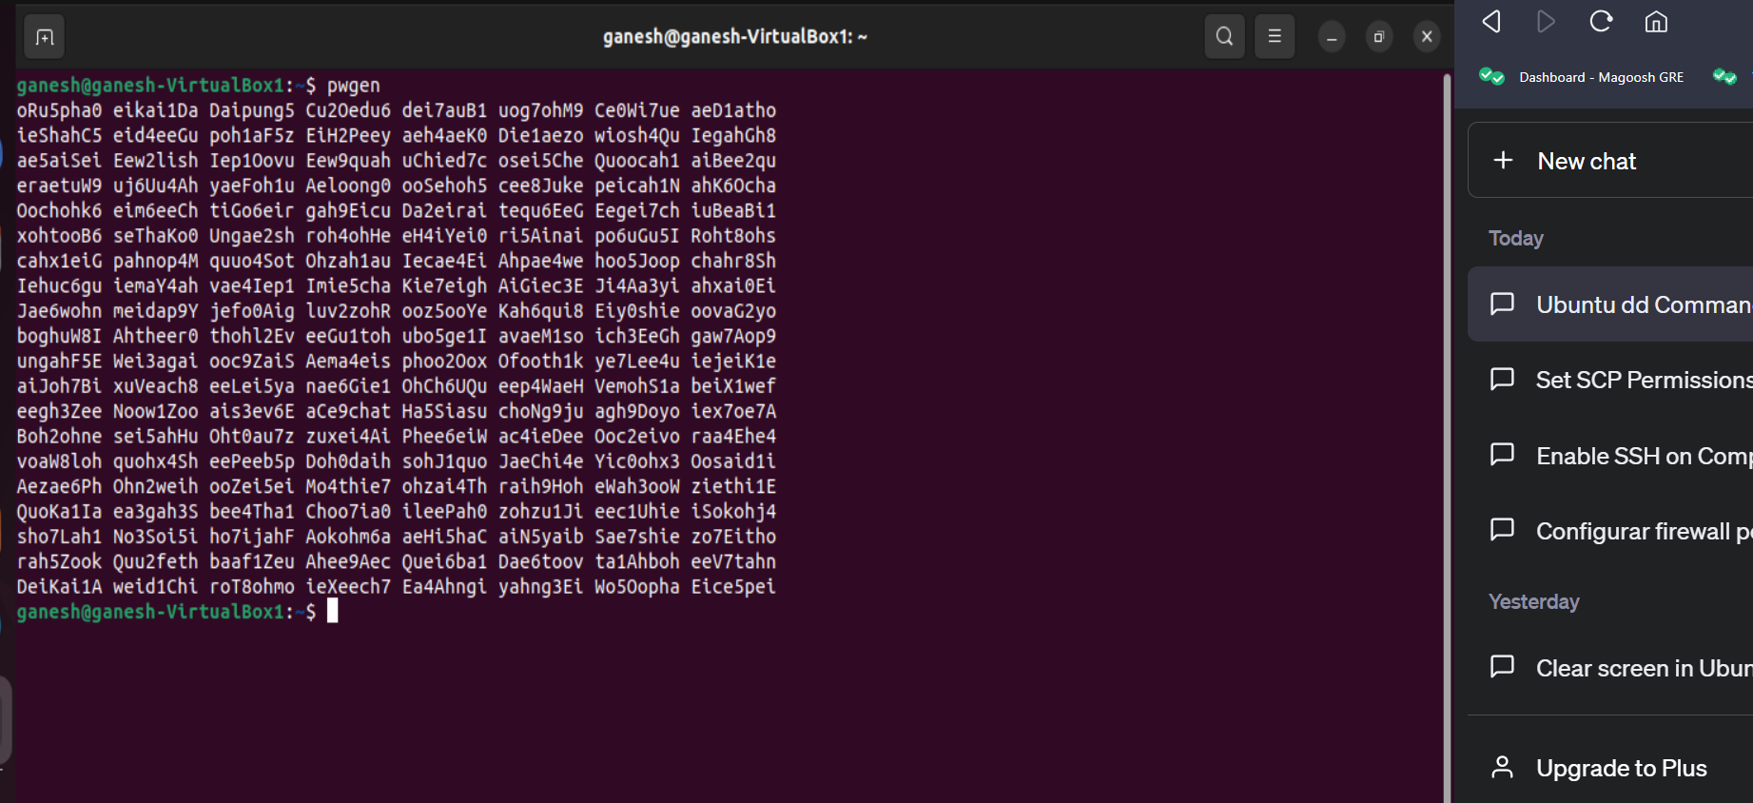

3.a.

4.a. In the system configuration of the VM, explain how changing the number of processors changes the behavior of your VM. Explain a scenario where you want to set this to the minimum, and a scenario where you want to set it to the maximum. Why is setting it to the maximum potentially a bad idea?

*- Processors determine the computing speed of any given task and the count of cores reflect the ability to run parallel tasks. In some instances, we might have to keep the number of processors allocated to a VM as minimal as possible when the workload doesn’t demand higher computing power so that even the host Operating System or other VMs can have significant CPU resources to run its processes. In addition to this, having a minimum number of processors can help save costs when setting up a cloud environment. On the other hand, allocating maximum number of processors can help in high workload environments such that the workload can be parallelly distributed on multiple processors/threads thus assisting in reducing time to complete a task. An example of this type could be for graphics processing. But allocating maximum number of processors may not be a good idea every time as it may result in higher cost for setting up and in environments where multiple VMs are deployed it would lead to CPU resource crunch, overhead and ultimately negative performance.*

4.b. In the system configuration of the VM, under the Acceleration Tab, explain the difference between the paravirtualization options: None, Legacy, Minimal, Hyper-V, and KVM. Explain which one would be best to use with Ubuntu Linux, and why.

*- Acceleration tab is used for improving the performance. The difference is highlighted as below:*

* *None – Paravirtualization is not used.*
* *Legacy – this is used for old VMs usually for backward compatibility.*
* *Minimal – minimal is used when there is no much modification required on the guest OS. The benefits lie between full and paravirtualization.*
* *Hyper-V – developed by Microsoft used for having multiple VMs generally for Windows guests.*
* *KVM – KVM is for Linux systems, makes the physical systems into Hypervisor and allowing the privilege of having multiple VMs.*

*KVM would suit well for Ubuntu Linux as Ubuntu has Linux Kernel and would integrate better with Linux environments.*

4.c. In storage devices when configuring the VM, there are multiple types of storage controllers: explain the difference between the IDE, SATA, and NVMe controller. Give an example for each type of storage controller of a scenario where you may want to use this type of controller.

* *IDE – IDEs are legacy controllers introduced in 1980s is typically used in Hard Disk Drives, Floppy drives. These lack speed and are not performance oriented. Example would be when we want to run old OS as it supports only controller types.*
* *SATA – SATAs are better than IDE in performance aspect and they even offer support to more devices compared to IDEs. SATA even support SSD devices. Example of this application would be for modern day Operating Systems and VMs*
* *NVMe – NVMes’ are faster and latest compared to the latter (SATA and IDE), used for SSDs, they offer low latency along with the support for parallelism too. Typical use case for NVMe would be for Data Intensive, performance focused database like SQL Server.*

4.d. In the network configuration of the VM, there are multiple types of network adapters: explain the difference between NAT, Bridged Adapter, Internal Network, and Host-only Network. Give an example for each type of network of a scenario where you may want to use this type of network.

* *NAT – stands for Network Address Translation, NAT provides the flexibility to assign multiple devices a single IP address. This blocks all external networks from accessing the VM, thus protecting the VMs. An example of this would be to allow internet connection for a virtual machine.*
* *Bridged Adapter – this configuration is used when external networks need to access the VMs, each VMs will have their own unique IP address. Use case for this configuration would be required when hosting a Web Server as it should be available to the public.*
* *Internal Network – This is required when we have multiple VMs and secure communication is required among them. This is used to create a private network in the Hypervisor. These types of networks can be useful for clustered databases.*
* *Host-only Network – Similar to Internal Networks, these types of networks can communicate with the host system and other VMs only and not to external networks since they are not connected to physical networking interface. Host-only is used when there is coordination is required between VMs for instance like a web server VM and a database VM.*

4.e. For the USB configuration of the VM, explain the difference between USB 1.1, 2.0, and 3.0 controllers

* *USB 1.1 – this provides universal support and a legacy technology, offering transfer speed of up to 12 Mbps.*
* *USB 2.0 – much faster than USB 1.1, this is a balance of speed and compatibility. This has transfer speeds of up to 480Mbps.*
* *USB 3.0 – this supports speed of up to 5Gbps, used for high-speed and large data transfer applications.*

5.a. Describe what a core and hardware thread is on a modern processor, and the difference between them?

- *Core is a processing unit which is part of a Central Processing Unit (CPU), a CPU can have multiple cores to support multitasking. A CPU can have up to 12 cores. Large application machines can have chores of around 48.*

*- Hardware thread is the ability of each core of a CPU to operate multiple tasks simultaneously. Each core can have multiple threads thus aiding in CPU utilization and performance(throughput).*

5.b. How many cores do the fastest processors from each manufacturer have? Give an example (specific model, specs, and price). (a) Intel CPU (x86) (b) AMD CPU (x86) (c) IBM CPU (Power9) (d) ThunderX CPU (ARM) (e) NVIDIA GPU

|  |  |  |  |  |  |
| --- | --- | --- | --- | --- | --- |
|  | **Intel CPU (x86)** | **AMD CPU (x86)** | **IBM CPU (POWER9)** | **THUNDERX CPU(ARM)** | **NVIDIA GPU** |
| Model | Core i9-13900KS | Ryzen 9 3990X | IBM Power9 | Cavium ThunderX | RTX 4090 |
| Cores | 24 | 64 | 24 | 48 | CUDA Cores- 16384 |
| Specs | 6GHz, 32 threads, 36Mb Cache | 4.3 GHz, 128 threads, Cache 288Mb | 512Kb L2 Cache, 10Mb L3 Cache | SoC, 2.5 GHz, 78K I-Cache, 32K D-Cache, 16MB of L2 Cache | 2.52 GHz, memory – 24GB GDDR6X |
| Price -$ | 699 | 3,995 | 4,000 | 1,795 | 1,599 |

5.c. Why do we not have processors running at 1THz today (as might have been predicted in the year 2000)?

- *There are multiple reasons for not having processors running at 1000GHz currently due to many reasons, few are listed below:*

* *Higher frequencies mean more power (more power consumption) which equates to higher heat dissipation. Even with top-notch colling systems will face challenge in cooling such high temperatures.*
* *Much software’s at the moment are not configured to fully utilize the processors of such high clock speed.*
* *Present day storage systems cannot cope up with the throughput.*
* *The time, resources and manufacturing costs involved for this development would not be viable.*

5.d. Describe Moore’s Law. Is it going to go on forever? If not, when will it end? Justify your answer to why it will end and when.

- *Moore’s Law is an observation made in 1965 by Gordon Moore, he stated that the number of transistors on an Integrated Circuit will double every two years. However, this might not hold true in the long run due to the current limitations and challenges:*

* *When transistors become smaller and smaller, they are prone to quantum effects, which will disrupt the behaviour of the transistor.*
* *As the transistor size decreases, the manufacturing costs will scale up and even the difficulty in fabricating them.*
* *Limitations of silicon like controlling leakage currents and heat management will be major challenge.*

6.a. Why is threading useful on a single-core processor?

- *Threading aid in efficient use of CPU Cores. While only one thread run at a given time for a single-core, having threading aids in switching between tasks more faster giving the illusion of parallel execution, maximizing utilization. Thus, assisting in responsiveness of the system and reducing latency effects.*

6.b. Do more threads always mean better performance?

- *This might not hold true every time. The most basic way is to match the count of threads to the count of CPU. Threading helps in throughput but not make the CPU faster, it helps in executing multiple tasks simultaneously and make efficient use of the CPU. A CPU with 4 cores and 4 threads would perform better than 2 cores and 4 threads.*

6.c. Is super-linear speedup possible? Explain why or why not.

- *Super-linear speedup would not be possible theoretically, but in practice we do see such cases rarely. Amdahl’s Law limits the maximum speedup. There are three key causes for super-liner speedup in parallel computing:*

* *Caching effects – Adding more processors increases total cache size, improving memory locality and reducing misses.*
* *Early backtracking – One thread finding an exception can trigger backtracking in others before more work is done.*
* *Optimization pruning, earlier termination.*

6.d. Why are locks needed in a multi-threaded program?

- *Locks provide access to shared resources, without them there would be data corruption as multiple threads would be trying to access the data (race condition) hence enforcing synchronization, they are also used to prevent Deadlocks from happening. Locks also help in distributing files for one thread at a time thus avoiding conflicts. In addition to this, locks also enforce that the threads run in order.*

6.e. Would it make sense to limit the number of threads in a server process?

- *It would be sensible to limit the number of threads in a server process. It mainly depends on the workload, resource availability. Having too many threads can limit the number of CPU cores resulting in conflict for the threads to share resources, resulting in performance degradation. Having lot of active threads means having large number of context switching which can cause overhead and diminish performance. For efficient use of resources, it is better to limit the threads based on operating conditions and use case.*